Name: ____________________ IPad#_____________

Unit 6: Energy & Phase Changes
Homework Packet
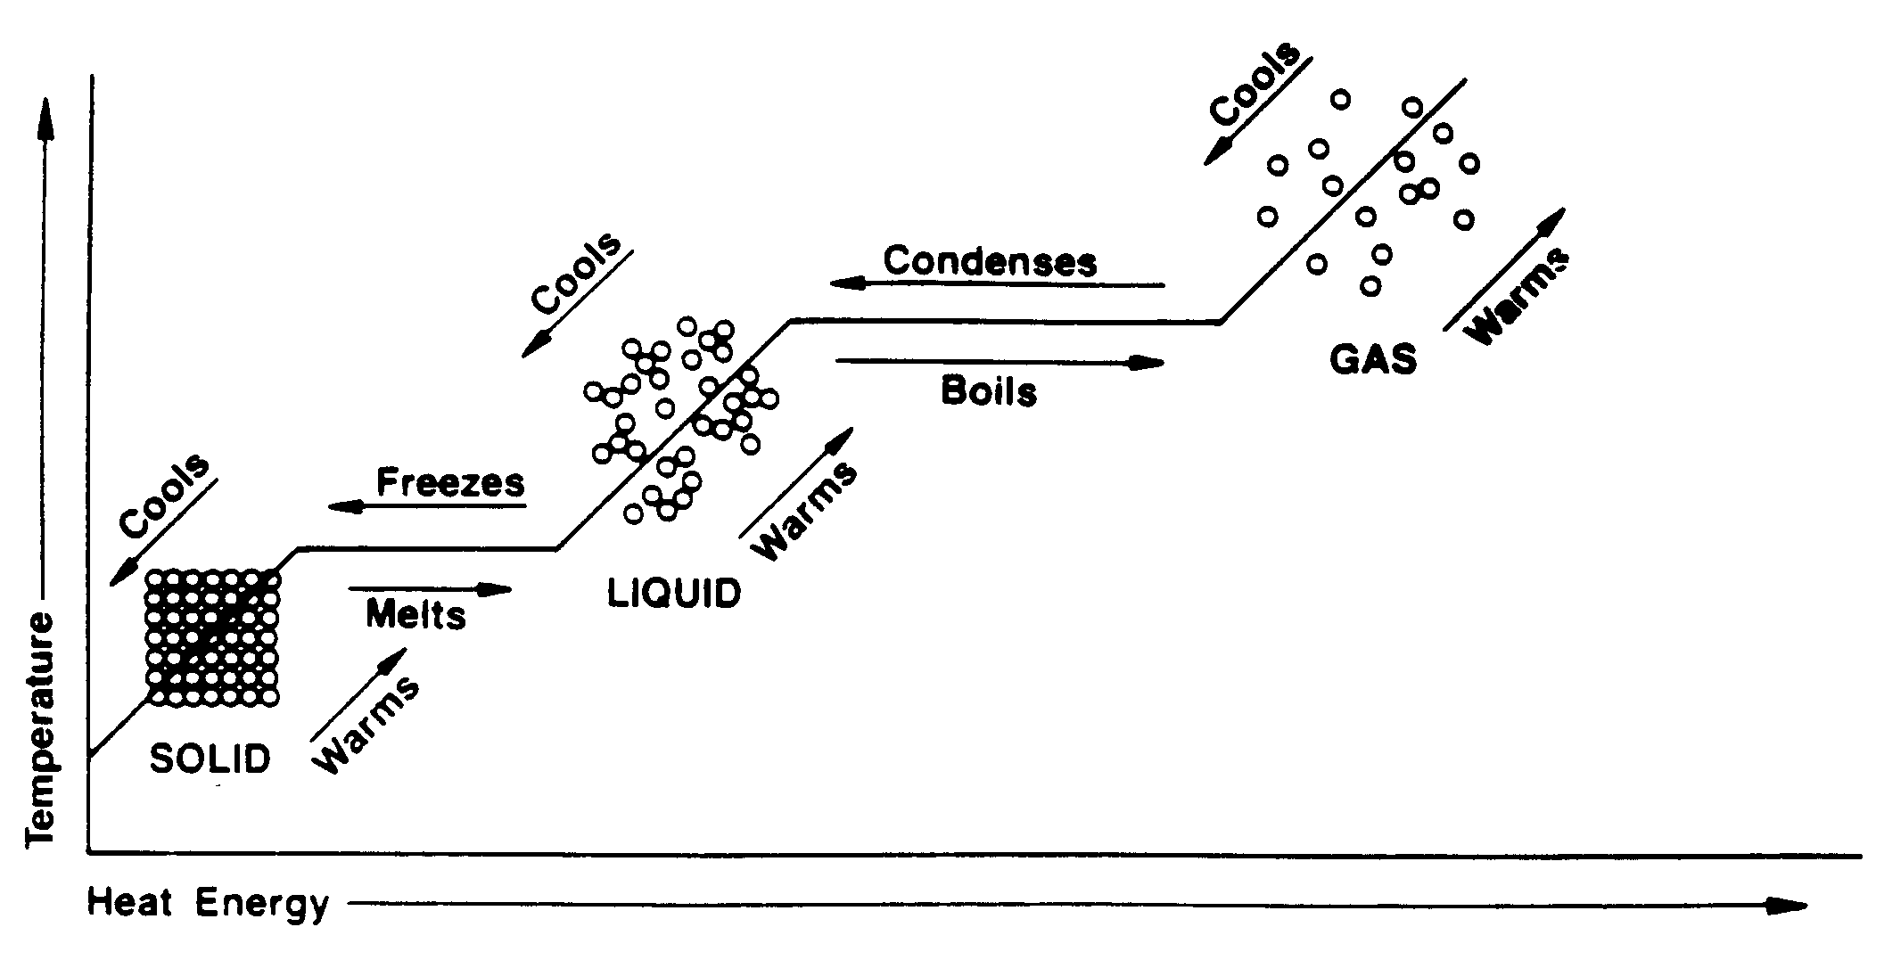

Textbook Chapters 13 & 17

HW packet Due:________________

Test Dates: Free Response:______________________
Multiple Choice:_____________________

Energy & Phase Changes Student Study Guide
Unit 6 Vocabulary List

Melting
Evaporation
Condensation
Freezing
Sublimation
Solid
Liquid
Gas
Heat
Temperature
Phase change diagrams
Heating/Cooling curves
Celsius
Kelvin
Heat of vaporization
Heat of fusion
Boiling point
Point of condensation
Freezing point
Melting point
Absolute zero
Law of Conservation of Energy
Kinetic energy
Potential energy
Exothermic
Endothermic
Vapor pressure
Joule

- What is Energy?
  - Energy: the capacity to do work or transfer heat
    - Kinetic Energy: the energy that an object has because of its motions
      - Kinetic energy is measured by temperature.
      - The greater the kinetic motion of the particles of a substance, the higher the temperature.
      - Associated with temperature change.
    - Potential Energy: stored energy of position
      - All forms of matter contain potential energy.
      - Associated with phase change, not temperature change.
      - Different phases of matter have different relative amounts of potential energy.
        - Solids have the least PE due to the close proximity (distance) between particles of the substance.
        - Gases have the most PE due to the far proximity between particles of the substance.
  - The Law of Conservation of Energy: During chemical or physical changes, energy cannot be created or destroyed but can be converted from one form of energy to another.
    - Exothermic changes release energy. Ex: H₂O(l) H₂O(s) + heat
    - Endothermic changes absorb energy. Ex: Fe + S + heat FeS
    - Chemical change almost always involves the breaking and forming of chemical bonds. Breaking bonds requires the input of energy (endothermic); Forming bonds results in the release of energy (exothermic).

- How Is Energy Measured?
  - Temperature: a measure of the average kinetic energy of the particles that make up a sample of any material.
    - Celsius scale: the calibration markings on a Celsius thermometer are based on two fixed points – the freezing point of water (0 C) and the boiling point of water (100 C). Note that the 0 degrees on this scale is an arbitrary (made-up; random) designation and does not refer to a zero quantity of any measurable property.
    - Kelvin scale (a.k.a. “absolute scale”): the zero point on the Kelvin scale represents the temperature associated with the theoretical total absence of kinetic energy and is known as absolute zero.
    - A temperature change of 1 Kelvin represents the same change in temperature as 1 Celsius degree. Thus, 0 C equals 273 K, and 100 C equals 373 K.
      - To convert from Celsius to Kelvin, K = C + 273 (Reference Table T)
      - To convert from Kelvin to Celsius, C = K – 273
    - A substance in one state may change to another state with a change in temperature.
  - Heat: the total energy of the particles in a substance
    - Heat is measured when the energy is transferred from one substance to another (i.e., unlike temperature, cannot be directly measured with a thermometer).
    - Heat is measured in the metric unit of joules (1000 J = 1 kJ).
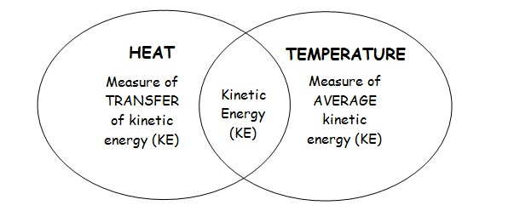
  - NOTE: Although there is a direct relationship between temperature and heat, they are not the same thing.

- Phase Changes
  - Phase changes are examples of physical changes.
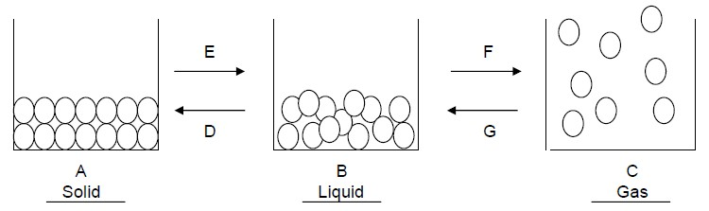
  - Almost all substances can be made to change between the 3 phases, simply by altering the temperature.

    - Solid to liquid (Arrow E) = melting
    - Liquid to solid (Arrow D) = freezing
    - Liquid to gas (Arrow F) = evaporation (open container); vaporization (closed container)
    - Gas to liquid (Arrow G) = condensation
    - Solid to gas = sublimation
    - Gas to solid = deposition
- Phase Change Diagrams: Heating & Cooling Curves
  - Heating Curve: Temperature vs. Time is graphed while a substance is being HEATED at a constant rate.
  - Cooling Curve: Temperature vs. Time is graphed while a substance is being COOLED at a constant rate.
  - The freezing point and the melting point of a substance are the same.
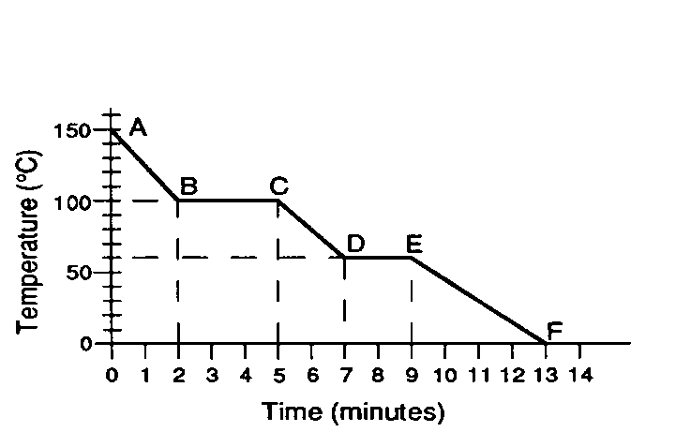
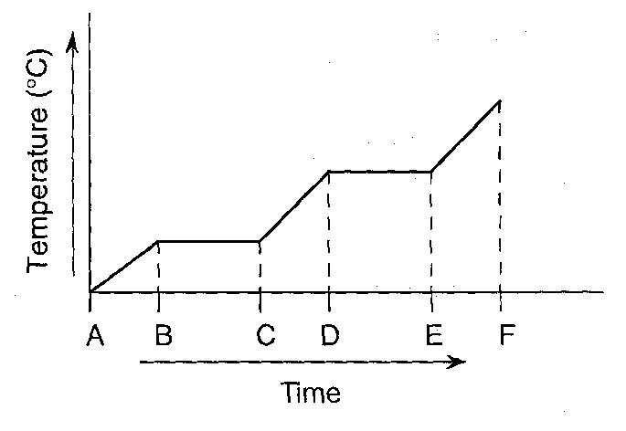
Cooling Curve
(exothermic)

(endothermic)

Heating Curve
(endothermic)

AB = Gas
BC = Condensation
CD = Liquid
DE = Freezing
EF = Solid
AB = Solid
BC = Melting (Fusion)
CD = Liquid
DE = Boiling (Vaporization)
EF = Gas

Note: There are kinetic energy changes when there is a change in temperature (sloped portions of the graph, i.e., AB). There are potential energy changes when there is a change in phase with no change in temperature (flat portions of the graph, i.e., BC).

- Measurement of Heat Energy (Potential Energy)
  - Heat: Energy transferred due to a difference in temperatures.
  - Specific Heat (c): the amount of heat needed to raise the temperature of 1 gram of water by 1 C.
  - The amount of heat lost or gained can be calculated using the following equation:

q = mcΔT

q = heat (units = Joules or J)
m = mass of sample
c = heat capacity of sample (see Table B for H₂O)
ΔT = change in temperature (T_{f}-T_{i})

This formula cannot be used to calculate heat change during phase changes because ΔT = 0.

  - The formulas for calculating heat in joules during changes of phase are listed on Table T.
  - Heat of Fusion: the energy absorbed (endothermic) to melt a sample of a solid to a liquid or the energy released (exothermic) when a sample of liquid freezes to a solid. (Table B for water)
    - Q = mH_{F}
  - Heat of Vaporization: the energy absorbed (endothermic) to vaporize a sample of a liquid to a gas or the energy released (exothermic) when a sample of a gas condenses to a liquid. (Table B for water)
    - Q = mH_{V}
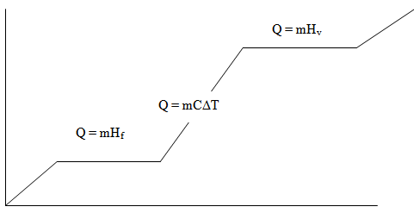

Energy & Phase Changes Homework
PHASES OF MATTER
Pg. 434
18. Tightly together in an orderly arrangement_____

PHASE CHANGE
Pg. 439
25. Weak intermolecular forces and high vapor pressures_____

Pearson SuccessNet Online: Chapter 13: Kinetics Art: Changes in State

VAPOR PRESSURE & BOILING POINT
Pg. 443
38. Standard temperature and pressure____
47. boiling pt.Temp at which vapor pressure equals external pressure___
Normal boiling pt.When external pressure is 101.3kPa____
56. a) 121 °c
b) Chloroform
c) Chloroform
d) external pressure on ethanol would need to increase & on ethanoic acid would decrease
e) 77°c

ENDO/EXOTHEMIC
Pg. 586
47. a) exothermic
b) glass beaker & air (if in water, than the water as well)
48. a) Exothermic
b) Endothermic

KELVIN TEMPERATURE
Make the following temperature conversions on the chart. Show the mathematical setup in the center column.
Celsius | Conversion setup | Kelvin
0º | 0 + 373 = | 273
177° | 450 - 273 = | 450
-40º | -40 + 273 = | 233
21° | 294 – 273 = | 294
-273º | -273 + 273 = | 0
-148° | 125 – 273 = | 125

Pg. 424
5. Kelvin temperature is directly proportional to the average kinetic energy
_________________________________________________________________

ENERGY AND ENERGY CALCULATIONS
Pg. 561
8. Heat floes from the blanket to your body. If your body is the system then it is
endothermic
Pg. 568
18.
Q=mcΔt
Q=(40g)(4.18J/g°c)(3°c)
Q= 501.6 J

Pg. 575
28. Same as each other but opposite in sign
_______________________________________________________________
31.
Q=mH_{f}
Q=(225g)(334J/g)
Q= 75150 J

Show all work including the formula. Circle your final answer with proper units and significant figures.
a. How many joules of heat are given off when 5.0 grams of water is cooled from 75ºC to 25ºC?
Q=mcΔt
Q=(5g)(4.18J/g°c)(50°c)
Q= 1045 J
b. How many joules does it take to melt 35 grams of ice at 0ºC?
Q= mH_{f}
Q=(35g)(334J/g)
Q= 11690 J
c. How much heat is needed to raise the temperature of 30. grams of water from 285K to 335K?
Q=mcΔt
Q=(30g)(4.18J/g°c)(50°c)
Q= 6270 J
d. How many joules of heat are released when 85 grams of steam condenses to liquid water?
Q=mH_{v}
Q=(85g)(2260J/g)
Q= 192100 J
e. How many joules of heat are required to melt 75 grams of iron metal at the melting point temperature of 1538ºC. The heat of fusion for iron is 247 J/g.
Q=mH_{f}
Q=(75g)(247J/g) Q= 18525 J
f. What is the specific heat of silver if a 93.9 g sample cools from 215.0ºC to 196.0ºC with the loss of 428 J of energy? Q=mcΔt 428J = (93.9g)(c)(19°) c= 0.240 J/g°c

g. If 100.0 J are added to 20.0 g of water at 30.0ºC, what will be the final temperature of water?
Q=mcΔt 100.0J=(20.0g)(4.18J/g°c)(Δt) Δt= 1.2°c Final Temp = 30.0 + 1.2 = 31.2°c
PHASE DIAGRAMS

Pg. 586
61. Heat is being used to melt the ice
________________________________________________________________

Base your answers to the following questions on the graph below, which shows 10.0 kg of a substance that is solid at 0°C and is heated at a constant rate of 60 kilojoules per minute.
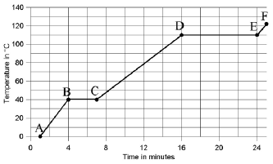

  - 40 What is the temperature at which the substance can be both in the solid and the liquid phase?
  - BC/DE During which lettered intervals is the internal potential energy of the substance increasing?
  - AB/CD/EF During which lettered intervals is the kinetic energy of the particles increasing?
  - 540 kJ How much heat is added to the substance from the time it stops melting to the time that it begins to boil?
  - 180 kJ What is the total heat needed to melt the substance?
  - 480 kJ What is the total heat needed to vaporize the substance?
  - 48 J/g What is the heat of vaporization of the substance?
  - AB During which lettered intervals is the substance solid?
  - CD During which lettered intervals is the substance in the liquid phase?
  - EF During which lettered intervals is the substance in the vapor phase?
  - 110°c What is the temperature at which the substance can be both in the liquid and the vapor phase?

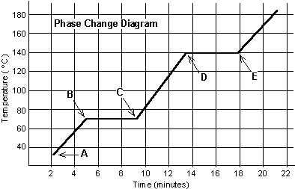
Using the diagram of the phase change of water below to answer the following questions

  - Does the graph above represent a heating curve for water? How do you know?

Heating. The slope is increasing
  - If energy is applied at a rate of 100 joules per min, how much energy does it take to melt the substance at its melting point?

4 x 100 = 400J
  - If the heat of fusion for this substance is 142 J/g, what is the mass of the substance being melted?
Q=mH_{f}
400 J = (m) (142J/g) m = 2.82g
  - What is the heat of vaporization for the substance?
Q=mH_{v} 500J = (2.82g)(H_{v}) H_{v}= 177.3 J/g

  - Is this heating curve endothermic or exothermic?
Endothermic- heat is added

Why Cold Doesn’t Exist
Directions: Before reading the article Why Cold Doesn’t Exist, in the first column, write “A” or “D,” indicating your agreement or disagreement with each statement. As you read, compare your opinions with information from the article. In the space under each statement, cite information from the article that supports or refutes your original ideas.
Me | Text | Statement
 | D | - Energy can be transferred from a colder to a hotter body.
 | A | - At a given temperature, all of the particles in a liquid have the same kinetic energy.
 | D | - In a sample of ice in a soft drink, the water molecules in both the ice and soft drink have the same kind of kinetic energy.
 | A | - Energy transfer is called heat.
 | A | - At thermal equilibrium, the number of molecular collisions resulting in energy gain is the same as the number of molecular collisions resulting in energy loss.
 | A | - When water evaporates from your finger, the water molecules with a lower average kinetic energy are left behind, so your finger feels cooler.
 | A | - The intermolecular forces between molecules of oil are less than the intermolecular forces between molecules of water.
 | A | - Cold is an adjective used to describe a lack of heat.

Why Cold Doesn’t Exist - Questions for Comprehension:
  - What happens when an ice cube is added to a soft drink?

Heat is transferred from drink to ice _________________________________________________

2. What is the rule about how energy is transferred between two objects that are in contact?
High to Low
_________________________________________________________________
- (T-F / Explain) All particles of a substance have the same kinetic energy.

False- they have different speeds so different Kinetic Energies
- What is the definition of temperature?

Measure of the average Kinetic Energy
_________________________________________________________________

- Name the three kinds of motion that a particle can have.

Vibrate, translate and rotate_______________
- Describe the results of collisions between faster-moving particles and slower-moving particles.

The faster moving particles will transfer energy to the slower moving molecules until their temperatures are the same.

- What term is applied to the situation in which energy has been transferred from faster particles to slower ones and as a result the particles end up traveling at the same speed?

Thermal Equilibrium
_________________________________________________________________

- Explain why evaporation of a liquid from our skin makes us feel cooler.

The water with higher energy vaporize leaving the water molecules with lower kinetic energy (temperature)

